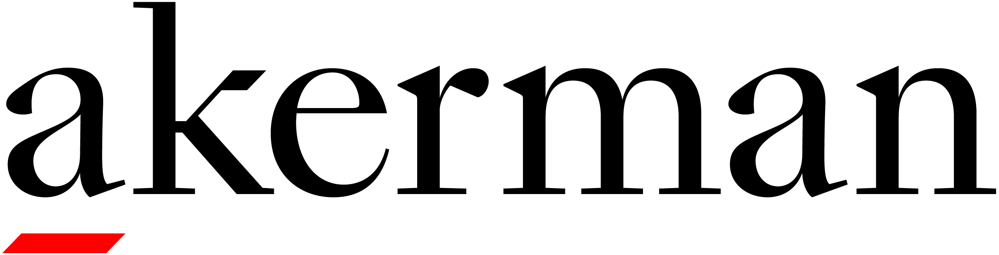
CONTINUING LEGAL EDUCATION (CLE) CREDIT REQUEST AND
ATTENDANCE ATTESTATION
TITLE/SUBJECT MATTER OF ACTIVITY: | The Future of Cosmetics Regulation is MoCRA - The Modernization of Cosmetics Regulation Act
DATE/TIME: | May 17, 2023 –2:00 pm – 3:00 m CST |  | LENGTH OF ACTIVITY: 60 minutes
LOCATION OF ACTIVITY (CITY/STATE): | Florida | PARTICIPATION FORMAT: |  | Live Webinar
FACULTY MEMBER(S): | Felicia Nowels, Li Massie, Akerman LLP
CLE CREDIT: | FL – 1 General Credit (Approved)

- This form is to request Continuing Legal Education (CLE) credit. Please only return this form if you would like to receive CLE credit.
- In order to receive CLE credit for this program please complete and submit this Attendance Attestation form within 3 business days to Barbara Maniscalco, CLE Manager at Barbara.maniscalco@akerman.com
- The CLE Attendance Verification Code will be read by the presenter during the program. Please listen for the code and note it in the field below. CLE Credit cannot be awarded if your attestation is missing the CLE verification code
- You will be contacted by the CLE Manager via email once CLE credit is approved.

I hereby attest to the session attendance that I have recorded on this form. Additionally, I attest that I received access to all course materials prior to the commencement of the program. I understand that failure to complete this attestation will result in denial of CLE credit by the provider.

NAME |  | BAR JURISDICTION AND BAR NUMBER | CLE ATTENDANCE VERIFICATION CODE (must be include to receive CLE credit for this presentation) | SIGN IN TIME | SIGN OUT TIME

